Jackson: A quest for better roads

Submitted to:
Jackson City Council

Submitted by:
David Sickmiller

May 31, 2002

Executive Summary
The purpose of this report is to describe the poor condition of roads in Jackson, Michigan and propose a solution to improve road conditions by following the example of other communities.
Roads in Jackson could definitely use improvement. Nearly a third of local city roads are considered to be in poor condition (R. McMunn, personal communication, April 23, 2002). However, since 33% of non-freeway miles are rated poor statewide, Jackson has competition for funding (MDOT, 2001, p. 14). Therefore, it seems that a solution must be very cost-effective.
Jackson is one of many communities seeking to improve road conditions while maintaining or decreasing costs. Sioux Falls, SD has successfully used spray injection to increase the life of pothole patches while decreasing labor costs (Skorseth, 2000). Dearborn, MI has saved money on repair by requiring warranties for materials and workmanship (Heinlein & Greenwood, 2003).
This report proposes a solution consisting of three parts. First, Jackson should invest in spray injection, a superior method of patching roads. While there is a significant initial cost, its operating costs are lower. Second, more funding should be spent on road repairs. Third, warranties should be requirement of warranties on the materials and workmanship of road builders.

Table of Contents
I. Executive Summary . . . . . . . . . . . . . . . . . . . . . . . . . . . . . . . . . . . . . . . . . ii
II. List of Illustrations . . . . . . . . . . . . . . . . . . . . . . . . . . . . . . . . . . . . . . . . . . iv
II. Introduction . . . . . . . . . . . . . . . . . . . . . . . . . . . . . . . . . . . . . . . . . . . . . . . 1
II. Methods of Research . . . . . . . . . . . . . . . . . . . . . . . . . . . . . . . . . . . . . . . . 2
III. Findings . . . . . . . . . . . . . . . . . . . . . . . . . . . . . . . . . . . . . . . . . . . . . . . . . . 4
1. Problem Description . . . . . . . . . . . . . . . . . . . . . . . . . . . . . . . . . . . . . . . 4
- State and National . . . . . . . . . . . . . . . . . . . . . . . . . . . . . . . . . 4
- Local . . . . . . . . . . . . . . . . . . . . . . . . . . . . . . . . . . . . . . . . . . . . 4
- Road Maintenance and Repair . . . . . . . . . . . . . . . . . . . . . . . . 5
- Political Details - Funding. . . . . . . . . . . . . . . . . . . . . . . . . . . 5
2. Solutions Used by Other Communities . . . . . . . . . . . . . . . . . . . . . . . . 6
- Spray Injection . . . . . . . . . . . . . . . . . . . . . . . . . . . . . . . . . . . . 6
- Warranties . . . . . . . . . . . . . . . . . . . . . . . . . . . . . . . . . . . . . . . . 7
IV. Conclusions . . . . . . . . . . . . . . . . . . . . . . . . . . . . . . . . . . . . . . . . . . . . . . . . 9
V. Recommendations . . . . . . . . . . . . . . . . . . . . . . . . . . . . . . . . . . . . . . . . . . . 10

List of Illustrations
Figure Page

1. Example of a local Jackson road in a state of disrepair . . . . . . . . . . . . . . . . . 1

Introduction
The purpose of this report is to describe the poor condition of roads in Jackson, Michigan and propose a solution to improve road conditions by following the example of other communities.
Just a cursory drive down several major and downtown roads in Jackson will be enough to inform the driver that there are problems with the roads. Enjoying a smooth ride may require weaving back and forth to avoid potholes or avoiding the road entirely. This report will focus on roads covered by the City of Jackson, which includes major downtown roads and local residential streets.
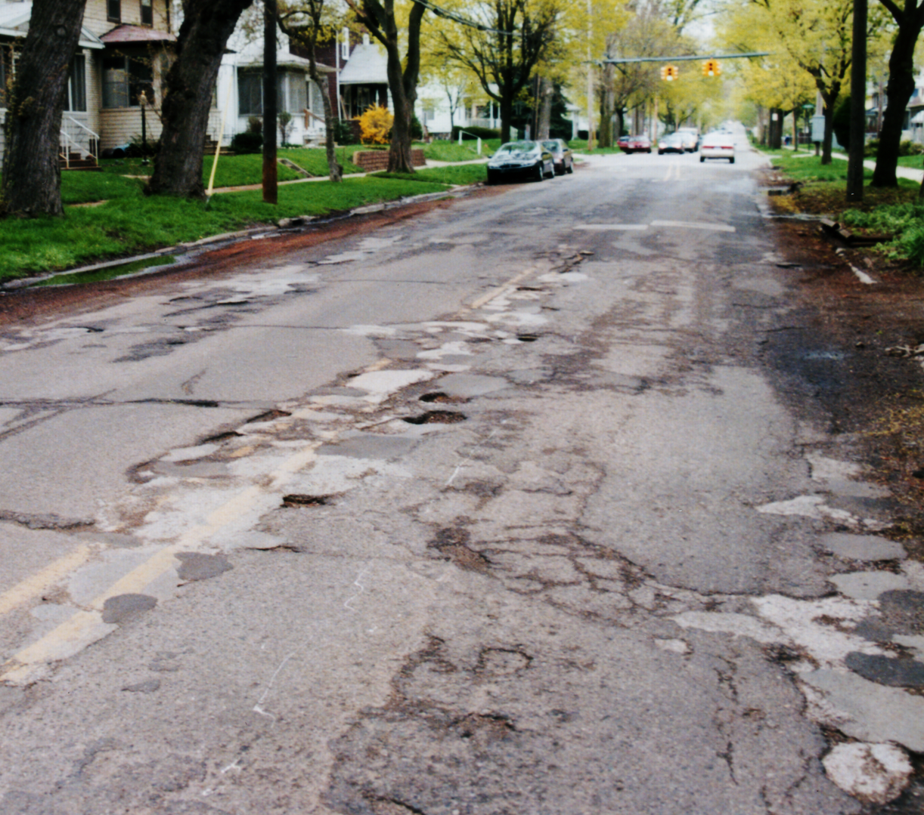
Figure 1. Example of a local Jackson road in a state of disrepair. Photo by author.
Jackson is one of many communities seeking to improve road conditions while maintaining or decreasing costs. This report utilizes the experiential knowledge gained by these communities to recommend a solution for Jackson. Two communities that will be analyzed are Sioux Falls, SD and Dearborn, MI.

Research Methods
To research the problem, a combination of local, state, and national sources has been consulted. The City of Jackson Engineering Department provided detailed information describing every main and local road in the city limits. The Jackson Country Road Commission, which oversees the roads outside of the city, has been contacted for similar information. These official accounts will also been supplemented by my personal observation and experience.
There are a number of useful websites describing both general pavement information and specific conditions in America and in Michigan. The Road Information Program is a “nonprofit organization that promotes transportation policies which relieve traffic congestion, improve air quality, make highway travel safer and enhance economic productivity” (The Road Information Project [TRIP], 2002, p. 1). In February 2002, TRIP released a 22-page report on Michigan roads prepared for Michigan’s Transportation Team (MTT). MTT “is a coalition of public and private sector organizations organized to protect and strengthen federal transportation funding for Michigan during authorization of the next federal highway bill to replace TEA-21” (TRIP, 2002, p. 1).
The Surface Transportation Policy Project (STPP) is a lobbyist group that released a report entitled, Potholes & Politics 1998 analyzing the funding for road repair at a national level. It is a very informative report, although biased towards increased funding of road repair.
The U.S. Department of Transportation’s Federal Highway Administration (FWHA) provides a wealth of information describing pavement maintenance options and conditions of interstate highways.
The Michigan Department of Transportation (MDOT) released a report in January 2001 describing the present state of roads in Michigan and the construction plans through 2005. MDOT has also provided a facts and figures report that describes many aspects of the current transportation policy.
The Kettering library contained a number of books relating to the construction and maintenance of pavement along with information specific to the highway system of Michigan.

Findings

Problem Description

State and National
Poor road conditions, such as potholes, rutting, and uneven pavement, are a common bane of drivers everywhere. The STPP reports in 1996 that on a national level, 16% of urban highway miles are in poor or mediocre condition (Dittmar, 1998). MDOT reports the pavement conditions in 1996 were 21% poor for freeway and 44% poor for non-freeway. MDOT also provides more recent data; in 1999, 14% of freeway miles and 33% of non-freeway miles received a poor rating (Michigan Department of Transportation [MDOT], 2001, p. 14).

Local
Randy McMunn, Assistant City Engineer of Jackson, reported there are 150 miles of roads in the City of Jackson, with 100 miles considered local roads and 50 miles considered major roads. According to their current data, about 30 miles of local roads and less than 5 miles of major roads were considered in poor condition. A new study is scheduled for completion in June 2002 (R. McMunn, personal communication, April 23, 2002).

Road Maintenance and Repair
Not only do bad roads cost drivers by increased wear on their vehicles, delaying a needed repair results in a more costly fix being required in the future. Particularly in Michigan, an open pothole can fill with water and freeze, weakening the surrounding material. If the foundation of the road is damaged significantly, the repair could involve digging up the entire road surface!
Filling potholes is probably drivers’ most common thought when they consider road repair. However, filling potholes is considered minor surface maintenance by the industry and is commonly referred to as patching. Applying a surface dressing such a chip seal is also considered regular maintenance (Watson, 1994).
More significant repairs involve resurfacing and reconstruction. As the term implies, resurfacing involves adding a new surface layer, or overlay, to the pavement. This technique is probably better known as resealing. Resurfacing can be considered maintenance because flexible pavement generally requires it around every 10 years (Watson, 1994). Reconstruction is a much more invasive and expensive operation. This is required when the roadbase, subbase, or subgrade no longer adequately support the surfacing layer. At this point, none of the above techniques will be effective. The road essentially has to be rebuilt from the bottom up.

Political Details - Funding
While the money for transportation comes from many sources, the states are the centers where the funds are distributed. Michigan generates revenue for its Michigan Transportation Fund (MTF) mainly from fuel taxes and license registrations (MDOT, 2002, p. 71). Michigan also gets funding from the Federal Highway Trust Fund, which is supported by the federal fuel tax. In fiscal year 2000, Michigan had revenue of $1.9 billion for the MTF. $639 million was designated for state trunk lines, $587 million for counties, and $333 million for cities and villages. In particular, Jackson County received $10.3 million, and the City of Jackson received $2.5 million. Michigan also received $720 million in federal funds for state highways (MDOT, 2002, p. 71).

Solutions Used by Other Communities
This subsection will describe two solutions used by other communities to improve the conditions on their roads. First is spray injection, a superior method of patching roads. While there is a significant initial cost, its operating costs are lower than the conventional method. Second, warranties on the materials and workmanship have been used to protect communities from substandard road construction.

Spray Injection
In 1995, Arlie Long, a recently retired street superintendent for Sioux Falls, S.D., convinced Sioux Falls’ mayor and city commission to purchase a truck-mounted spray injection machine (Skorseth, 2000). Their cold winter, a similarity between South Dakota and Michigan, was causing “eighty to ninety percent of the pothole patches” to fail after just one winter (Skorseth, 2000, para. 1). Previously, the city was using the conventional cold-mix method to hand patch potholes. The spray injection method of patching is more effective than conventional hand patching because the technique requires less labor and has a longer patch life.
Skorseth reports, “The Strategic Highway Research Program (SHRP), a federal research initiative, determined in its 1991 study of patching methods that spray injection is the most effective method of repairing potholes because of a longer patch life” (2000, para. 5). Spray injection does not require intensive labor. Support equipment required by conventional techniques, such as a cutter, tamper or roller, are not needed for spray injection. It also is accomplished via a towed unit or truck-mounted machine (Skorseth, 2000).
The Federal Highway Administration (FWHA) describes how the spray injection pothole patcher works:
Asphalt mixes basically consist of two components: the aggregate, which provides the structure for the mix, and the asphalt binder, which "glues" it all together. The spray-injection pothole patcher has two separate storage tanks: one for the aggregate and the other for the asphalt binder. The asphalt and aggregate are mixed as they travel under pressure through the machine's spray hose; the mix is then sprayed into the pothole, filling it. A layer of aggregate is then placed on top of the patched area.
The procedure is fast, simple, and efficient. Work crews spend less time toiling dangerously close to traffic, and motorists spend less time waiting for the patch to be applied. The pavement can be opened to traffic almost immediately after patching. (n.d., paras. 1-2)

Warranties
In Dearborn, a freeway bridge over the Rouge River was discovered to be cracked and is being redone. It was resurfaced just last year as part of a major road project on M-39, the Southfield freeway. The Detroit News reports, “The road builder is picking up the cost, because this time the cracks were discovered before the job was officially completed. A five-year warranty, covering materials and workmanship, also protected taxpayers” (Heinlein & Greenwood, 2003, para. 2). The state transportation chief says, “taxpayers shouldn't have to pay to fix road work that doesn't hold up for 10 years, half the minimum of 20 years a new or rebuilt highway is supposed to last” (Heinlein & Greenwood, 2003, para. 8).
Gaylord provides an example of the cost of not requiring warranties for road construction. Heinlein and Greenwood (2003, para. 30) write, “In 1996, the state spent more than $6 million to repave both sides of Interstate 75 for an 18.6 mile stretch near Gaylord. . . The asphalt surface over the new paving broke up and had to be replaced again three years later. Cost to taxpayers: $3.6 million.”

Conclusions
This section will focus on why the solutions above are suitable for the situation in Jackson.
Roads in Jackson could definitely use improvement. Nearly a third of local city roads are considered to be in poor condition. (R. McMunn, personal communication, April 23, 2002) However, since 33% of non-freeway miles are rated poor statewide, Jackson has competition for funding. (MDOT, 2001, p. 14) Therefore, it seems that a solution must be very cost-effective.
Jackson’s cold winters ravage local roads, both causing new problems and weakening previous patches. This is the same as the problem faced by Sioux Falls, SD. Jackson is not currently using spray injection, and should benefit by its adoption. Also, Jackson cannot afford a multimillion-dollar mistake like the one made in Gaylord. Requirement of warranties on the materials and workmanship of road builders can protect Jackson as exemplified by the bridge over the Rouge River.

Recommendations
This section will outline a specific course of action that will improve the road conditions in Jackson.
First, Jackson should invest in spray injection, a superior method of patching roads. The cold winters ravage local roads, both causing new problems and weakening previous patches. This is the same as the problem faced by Sioux Falls, SD. While there is a significant initial cost, its operating costs are lower.
Second, warranties should be requirement of warranties on the materials and workmanship of road builders. As this generally applies to only new construction or major reconstruction, this is considered a long-term strategy. Having a prematurely deteriorating road without a warranty would be an costly position for the city.

More Funding
This topic was not directly researched for other communities, but is worth consideration. Some claim that most social problems can be fixed with increased public funding. However, very few taxpayers would appreciate giving the government more money. It is well understood that the funding for road repair directly affects the quantity of roads which can receive repairs. An increase in taxes generally requires either great public support or an emergency situation. Despite their deficiencies, Jackson roads are not in a state of emergency, and there is not an overwhelming outcry for better roads. Dittmar (1998, para. 5) reports, “In a 1995 poll conducted by Lake Research, when asked which kind of transportation projects were a priority for their local community, voters overwhelmingly chose ‘fixing roads and bridges’ (49 percent).” Only 17 percent chose building new highways as a priority (Dittmar, 1998). Thus, to produce more funding for repair, the funding for new construction should be tapped.

Bibliography
Dittmar, H. (1998). Potholes and politics 1998. Retrieved April 20, 2002, from the Surface Transportation Policy Project Web site: http://www.transact.org/Reports/Potholes/title.htm
Heinlein, G. & Greenwood, T. (2002, April 29). State demands roads that last. The Detroit News. Retrieved May 30, 2002, from the Detroit News Web site: http://detnews.com/2002/metro/0204/30/a01-477232.htm
Federal Highway Administration. (n.d.). How does the spray-injection pothole patcher work? Retrieved May 30, 2002, from the Federal Highway Administration Web site: http://www.fhwa.dot.gov/winter/roadsvr/spray.htm
Michigan Department of Transportation. (2001). 2001-2005 five-year road and bridge program. Retrieved April 20, 2002, from the Michigan Department of Transportation Web site: http://www.mdot.state.mi.us/5yrplan-vol3/5year2001.pdf
Michigan Department of Transportation. (2002). Michigan transportation facts and figures. Retrieved April 30, 2002, from the Michigan Department of Transportation Web site: http://www.mdot.state.mi.us/planning/facts.htm
The Road Information Project. (2002). Michigan’s roads and bridges: Condition and future needs. Retrieved April 21, 2002, from the Road Information Project Web site: http://www.tripnet.org/MichiganStudy2002.pdf
Skorseth, K. (2000). Easy come, easy go: smooth road repair [Electronic version]. American City & County, 115 (1), 44-45, 49-52.
Watson, J. (1994). Highway construction and maintenance (2nd ed.). Harlow, England: Longman Scientific & Technical.

